

CS-3001

Network Security

Assignment 02

Submitted by: Sarita Sangrez
Roll number: 23i-2088
Date: 10th November 2025

Table of Contents

Introduction 4
Configuration 4
Rhosts File Creation in X Terminal 5
Tcpdump Run on Attacker and Rsh on Trusted Server 6
Addition of Permanent MAC address of Trusted Server in X Terminal 7
Stopping Trusted Server (simulated SYN flood) 7
Spoofing the SYN 8
Capturing the SYN+ACK 8
Completing the handshake and delivering the rsh payload 8
Setting Up a Backdoor 10
Troubleshooting and Observations 12
Conclusion 13

Introduction
This lab simulates the classic Mitnick attack in a controlled SEED Labs environment to demonstrate how weak TCP authentication and trust relationships (rsh/.rhosts) can be exploited for unauthorized access. Working inside the provided Docker-based network, I acted as an on-network attacker and used packet-level spoofing and sniffing to impersonate a trusted host (10.9.0.6) to an X-Terminal (10.9.0.5). The exercises progressed from crafting and injecting spoofed TCP SYNs, to capturing SYN+ACK sequence numbers, to completing TCP handshakes and delivering rsh payloads, and finally to planting a persistent backdoor by writing + + into the victim user’s .rhosts. I automated the time-critical parts with a Scapy-based tool (mitnick_auto.py) to ensure reliable packet timing, L2 forging, and deterministic sequence/ack handling; tcpdump and container inspection were used to verify each step.

Configuration

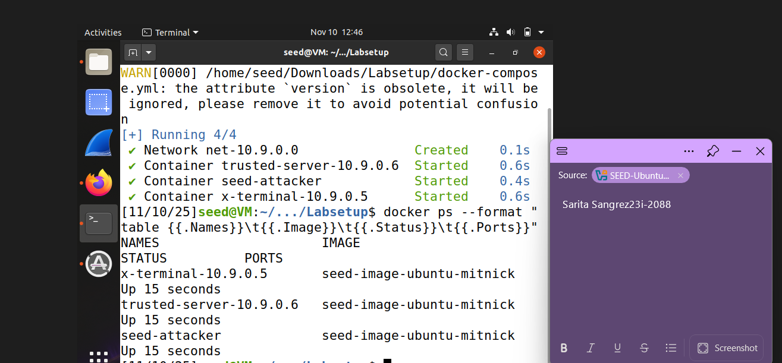

Rhosts File Creation in X Terminal
The first step in this experiment was to configure trust between the X-Terminal and the Trusted Server. This was achieved by creating an .rhosts file inside the X-Terminal container and adding the IP address of the Trusted Server. The .rhosts file essentially allows remote hosts to connect without requiring a password, thereby simulating the trust relationship that Mitnick exploited in his attack. By adding the Trusted Server’s IP, we ensured that subsequent remote shell (rsh) connections would be permitted, replicating the weak authentication practices of legacy systems.

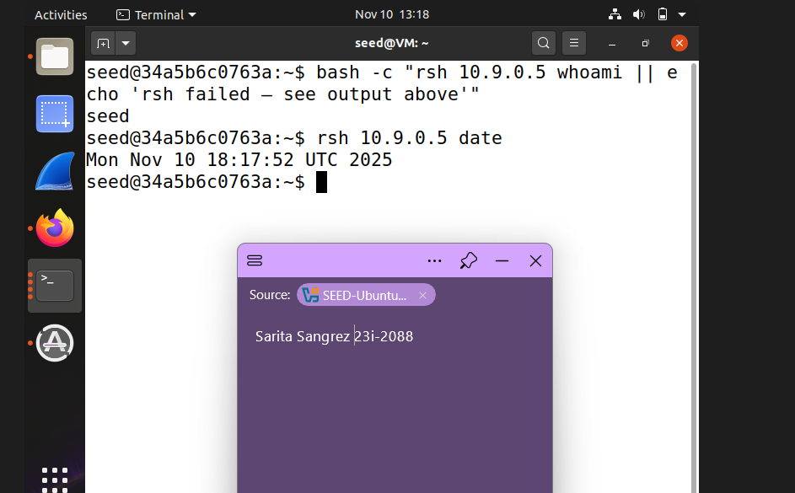

Tcpdump Run on Attacker and Rsh on Trusted Server
Next, I used tcpdump on the attacker container to capture network traffic while initiating a rsh session from the Trusted Server to the X-Terminal. The goal was to observe the TCP three-way handshake, and particularly the SYN+ACK packet sent by X-Terminal. By analyzing this packet, I was able to extract the TCP sequence number, which is critical for successfully spoofing a TCP session.

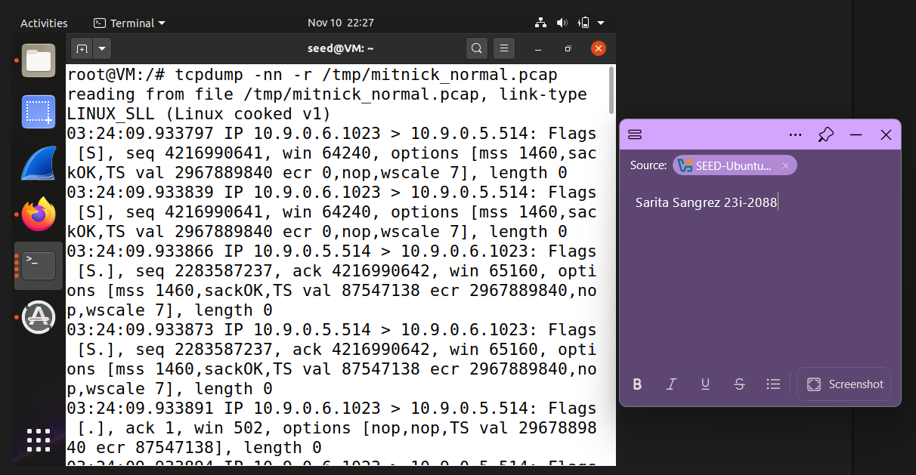

Addition of Permanent MAC address of Trusted Server in X Terminal
Since ARP cache entries may expire, I added a static MAC entry for the Trusted Server in the X-Terminal. This guaranteed that even if the Trusted Server went down (as it would during the SYN flooding simulation), X-Terminal would still attempt to respond using the cached MAC address. This step was crucial to simulate the conditions of the Mitnick attack, where the attacker relied on cached ARP information to impersonate the Trusted Server.

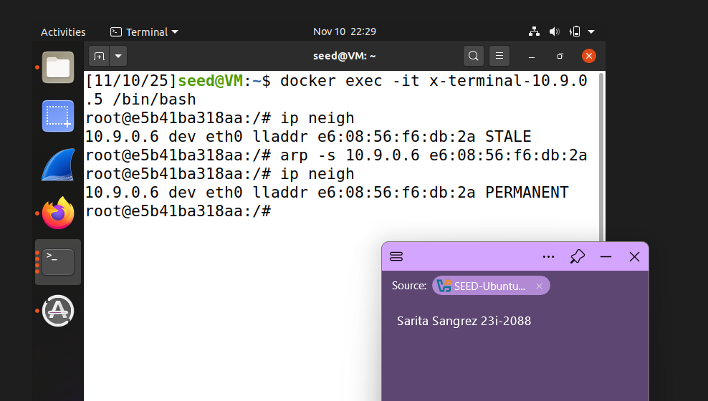

Stopping Trusted Server (simulated SYN flood)
Since I could not perform an actual SYN flood in this environment, I simulated its effect by shutting down the Trusted Server container. This replicated the condition in which the server is muted and unable to reset half-open connections. In the real Mitnick attack, SYN flooding was used to desynchronize the Trusted Server, preventing it from interfering with the spoofed session.
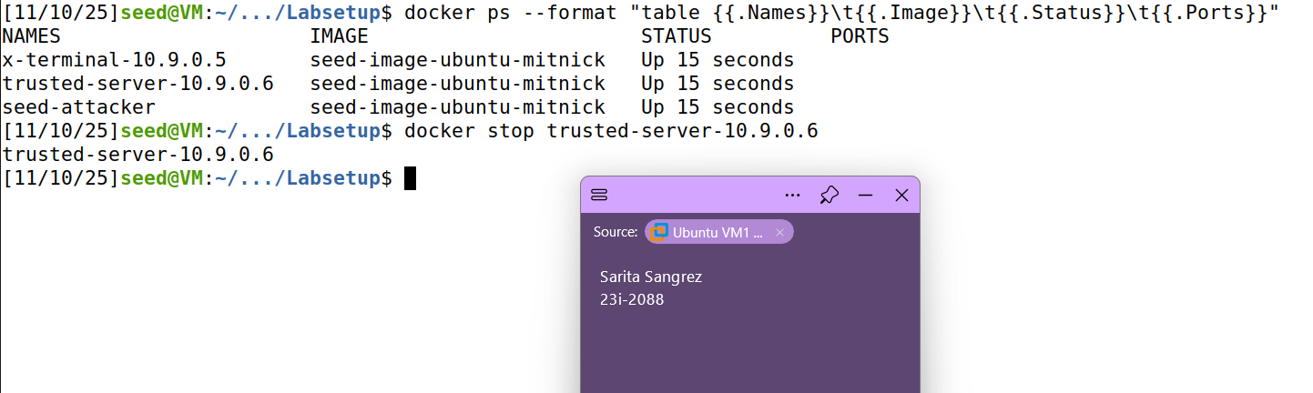

Spoofing the SYN
To begin Task 2, I launched our mitnick_auto.py script from the attacker container to fabricate the initial TCP SYN that appeared to come from the trusted server (10.9.0.6) and target the X-Terminal’s rshd port (10.9.0.5:514). The spoofed SYN used source port 1023 (the trusted service port) and a chosen initial sequence number; the attacker sent this packet at layer-2 with the trusted server’s MAC so that X-Terminal would accept it as coming from the trusted host. Tcpdump confirmed the outgoing SYN from 10.9.0.6:1023 toward 10.9.0.5:514, which triggered the expected response from X-Terminal.

Capturing the SYN+ACK
Immediately after the spoofed SYN was emitted the script sniffed the network for the X-Terminal’s SYN+ACK reply. The script’s BPF filter limited captures to SYN+ACKs from 10.9.0.5:514 destined to 10.9.0.6:1023, so the captured packet contained the server’s initial sequence number (ISN). Extracting that ISN from the captured packet is the critical step: it supplies the exact acknowledgment value the attacker must use to look like a legitimate TCP peer.

Completing the handshake and delivering the rsh payload
Using the ISN obtained from the SYN+ACK, the script immediately sent an ACK that completed the three-way handshake (seq set to the spoofed client’s next sequence, ack = server_ISN+1). On the same 4-tuple the script then sent a PSH+ACK carrying the rsh data payload (for example 1022\x00seed\x00seed\x00date\x00 or touch /tmp/xyz\x00), which is exactly how an rsh client submits the port, client uid, server uid and command. Because the handshake had been properly completed and sequence/ack numbers matched the server’s expectations, X-Terminal accepted the payload and acknowledged receipt.

The script

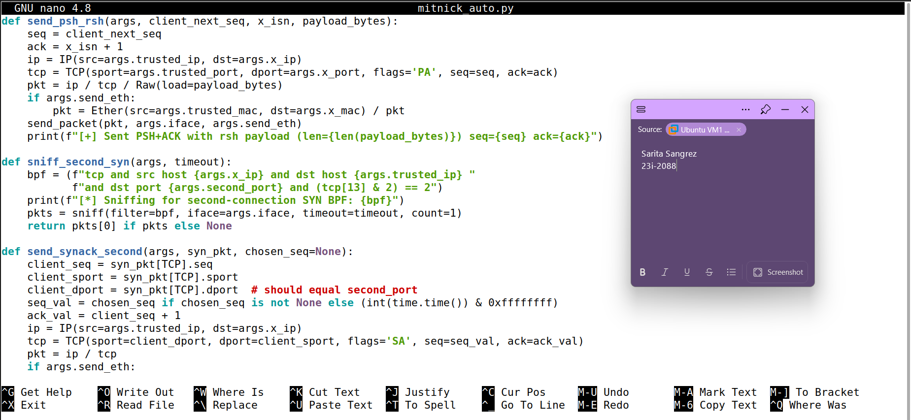

The output

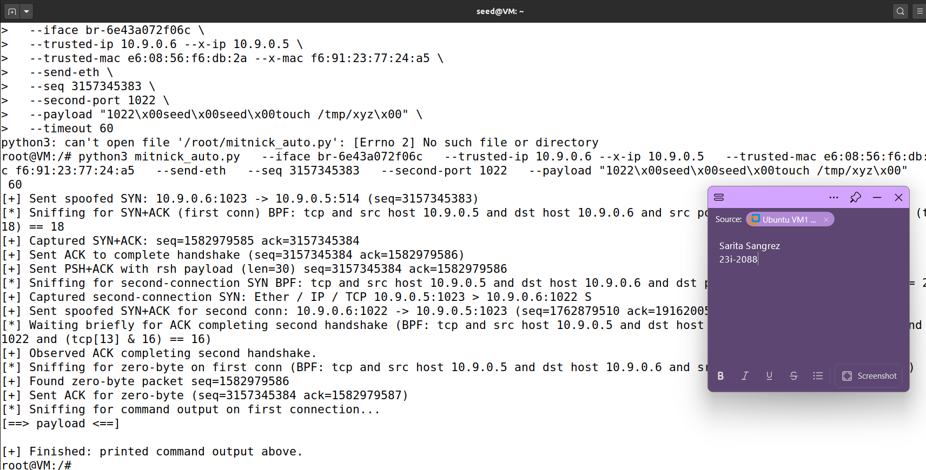

After running with payload "1022\x00seed\x00seed\x00date\x00"

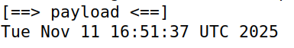

The logs
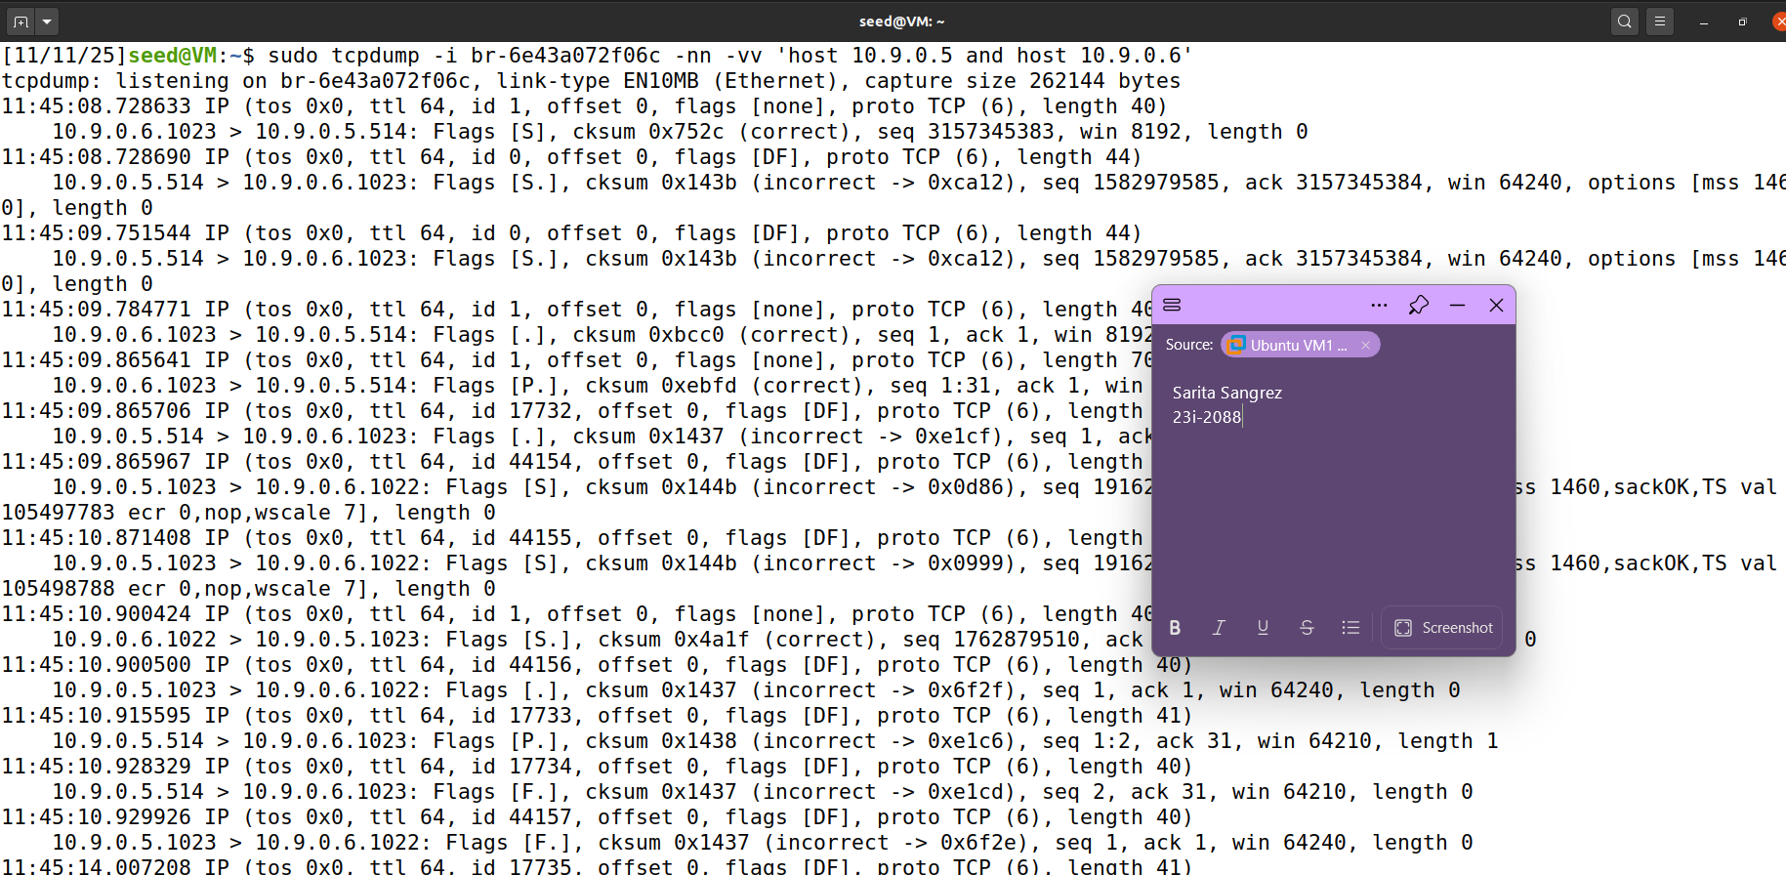

Setting Up a Backdoor

For Task 3 I planted a persistent backdoor on X-Terminal so the attacker can later access the machine without repeating the Mitnick spoofing sequence. The backdoor leverages rsh’s trust mechanism: by adding the single line + + to the victim user’s ~/.rhosts file the rsh daemon will trust any host and any user for that account, allowing passwordless remote shells. In the lab this demonstrates how an attacker, once able to run a single remote command via the spoofed rsh connection from Task 2, can gain persistent, unauthenticated access.

Payload and execution
Instead of sending a benign test command like touch or date, the rsh request delivered an echo command that wrote the backdoor line into the seed user’s .rhosts file. The payload encoded for rsh was 1022\x00seed\x00seed\x00echo '+ +' > /home/seed/.rhosts\x00, where 1022 is the privileged port used for the rsh stderr connection and seed is the username used in the lab. I reused the automated tool (mitnick_auto.py) that successfully performed the first connection (spoofed SYN → sniffed SYN+ACK → ACK to complete handshake) and then sent the PSH+ACK with this rsh payload. After the first payload was accepted, the script sniffed the server’s second-connection SYN and replied with a spoofed SYN+ACK to complete the second handshake so rshd would execute the command; the script then handled the zero-byte/ACK exchange as needed.

Verification
Because X-Terminal runs as a Docker container in the lab, verification was straightforward: I located the container with IP 10.9.0.5, entered it with docker exec, and inspected /home/seed/.rhosts. The file existed and cat -v showed a single line containing + +, confirming the backdoor was written exactly as intended. To validate the practical effect, I installed an rsh client on the attacker container (apt-get install rsh-redone-client) and executed rsh 10.9.0.5 -l seed 'whoami'; the command returned seed without prompting for a password, demonstrating true remote login without password.

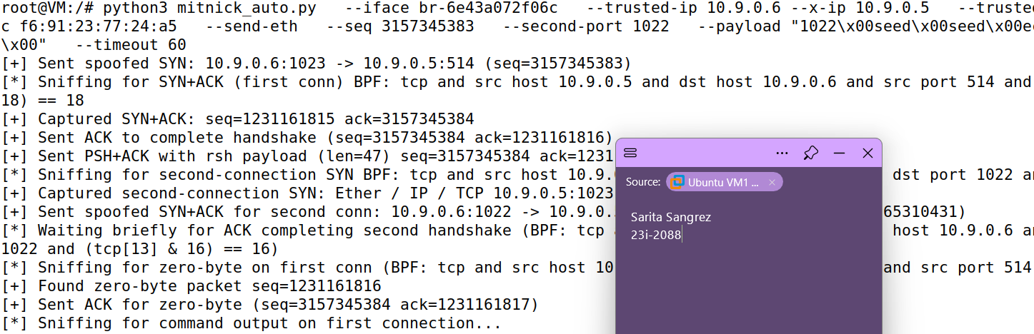

Results on X-Terminal

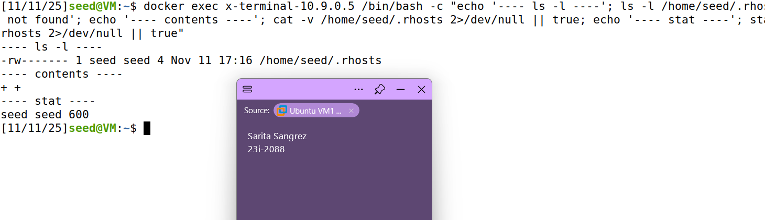

Verify on Attacker

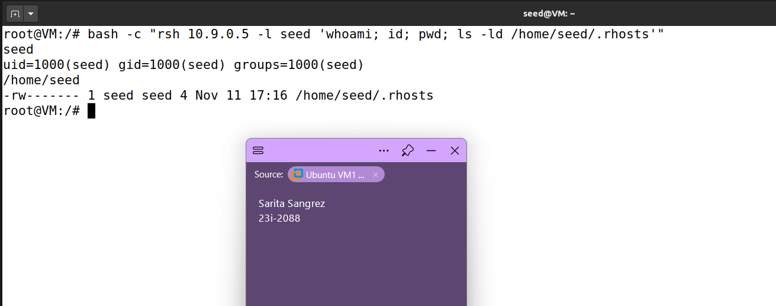

Troubleshooting and Observations

Observations
- Spoofed SYN from 10.9.0.6:1023 reliably elicited a SYN+ACK from 10.9.0.5:514 when L2 MACs matched expected values.
- Capturing the SYN+ACK allowed extraction of the server ISN; using ack = server_ISN + 1 completed the TCP three-way handshake.
- Sending PSH+ACK with correctly set seq/ack delivered the rsh payload and was acknowledged by X-Terminal.
- X-Terminal attempted the rsh second (stderr) connection to the privileged port specified in the payload (we used 1022); replying with a spoofed SYN+ACK completed that handshake.
- Using date as the payload produced readable output captured by tcpdump; using touch created a file on the target (verifiable inside the container).
- When Ethernet source MAC did not match X-Terminal’s ARP expectation, packets were ignored or reset. So, forging MACs for L2 sends was necessary in this lab.
- Some packets displayed “(incorrect -> …)” checksums in tcpdump due to NIC checksum offloading; this is normal and not an on-wire corruption issue.
- Timing matters: replying immediately to sniffed SYN/SYN+ACK events (or using the automated responder) removed most timing-related failures.

Troubleshooting steps
- Always start tcpdump/sniffer before sending the spoofed packet so the SYN+ACK is not missed.
- Use an L2 send (Ether + IP + TCP) and set the Trusted MAC (--send-eth) so X-Terminal sees the expected source MAC.
- Use a privileged second-port e.g. 1022 in the rsh payload. rshd expects a privileged port for the stderr connection.
- Increase sniff timeouts (e.g., --timeout 60 or 120) when packets retransmit slowly or the host is noisy.
- If X-Terminal sent RSTs or unexpected responses, temporarily drop local kernel RSTs on the attacker with iptables during testing:
sudo iptables -A OUTPUT -p tcp --tcp-flags RST RST -j DROP (remove after test).
- When timing is tight, use an auto-responder script (the provided mitnick_auto.py) that sniffs and replies immediately to SYN/SYN+ACK rather than manual commands.
- If scapy raised “No such device” or interface errors, double-check the interface name (use ip a) — container networks can expose bridge interfaces (e.g., br-6e43a072f06c).
- If scapy code errors occurred (syntax/type bugs), back up and patch the script (I fixed a time.time() int cast bug).
- Capture a full pcap when confused: sudo tcpdump -i br-... -w /tmp/mitnick.pcap 'host 10.9.0.5 and host 10.9.0.6' and inspect with tcpdump -r or Wireshark.
- Verify .rhosts contents with cat -v /home/seed/.rhosts to ensure there are no hidden characters (must be exactly + +).
- To verify file creation, locate the container by IP and docker exec into it, then ls -l /tmp/xyz or cat /home/seed/.rhosts.
- If rsh client missing on attacker, install rsh-redone-client (apt-get update && apt-get -y install rsh-redone-client) to test passwordless login.

Conclusion
The lab proved that, in a permissive network and with legacy rsh trust mechanisms, an on-network attacker can fully impersonate a trusted host and execute arbitrary commands on a victim machine — even establishing persistent passwordless access by modifying .rhosts. Key takeaways are that correct sequence/ack manipulation, MAC/address consistency, and timing are essential to the attack’s success, and that automation greatly improves reliability. From a defensive perspective, the exercise highlights why rsh/.rhosts are obsolete and dangerous, why TCP defenses (randomized ISNs, ingress/egress filtering, and avoiding MAC-based trust) matter, and why modern secure practices (use SSH with strong authentication, remove .rhosts, restrict privileged ports, and monitor anomalous TCP activity) should be enforced to prevent similar compromises.

